POLAR Telecon Agenda for May 5, 2006

Agenda:

0. Upcoming Polar Telecon
1. Operations
2. Polar SWT Meeting
3. Resident Archives White Paper
4. MFE Data Processing Status
5. CAMMICE Science Report (continued)

0. Upcoming Polar Telecon

Friday, May 5, 2006
4 pm ET, 3 pm CT, 2 pm MT, 1 pm PT
PIs and their designated representatives will be telephoned at their usual numbers.
Other participants may call in at:
800-857-6258, password POLAR TELECON
(Leader: John Sigwarth)

The web site for the final agenda will be:
http://pwg.gsfc.nasa.gov/polar/telecons/2006May05/

Future Polar Telecons

Next telecon: Friday July 14th, 2006

Future Telecon Science Discussion Schedule
[Errors/omissions/preferences to: nicola.fox@jhuapl.edu]

July 2006: VIS
August 2006: EFI
September 2006: TIMAS
October 2006: Hydra
November 2006: MFE
December 2006: CEPPAD
January 2007: TIDE
February 2007: PIXIE
March 2007: SEPS
April 2007: UVI
May 2007: MDI
June 2007: CAMMICE

1. Operations

If you have any concerns about Polar operations, please contact Nicky Fox (nicola.fox@jhuapl.edu)

GTM Upset

At approximately 2011 UTC on DOY 108 (18 April), the Polar GTM (GGS Telemetry Module) experienced an upset. The upset occurred during the unattended period between supports (D27 EOT at 1545 UTC and D45 BOT at 2305 UTC). The CEPPAD, EFI, TIMAS, MFE, and HYDRA instruments were affected. TIDE telemetry appeared nominal. On 109/0743 UTC, there was a format change from contingency (Science mode 2) to science. At 1242 UTC, the procedure was initiated with commands to recover the GTM. The following commanding was part of that procedure:
UTC Instrument action
12:42:14 MFE ADC turned OFF
12:46:26 MFE ADC turned ON
12:47:30 MAG electronics turned OFF
12:49:35 MAG electronics turned ON
12:50:54 HYDRA write protect enabled
13:04:50 TIMAS HVM OFF
The recovery of TIMAS continued with the next support and was completed at ~1655 UTC. The MFE RTC was executed during the next support beginning at 2120 UTC. CEPPAD and EFI appear to have recovered without direct intervention.
Polar GTM Upset History:
GTM-1 Upset Events
- May 6, 1998 (DOY 126, 08:15:27)
- September 30, 1998 (DOY 273, 14:00:05)
- October 22, 1998 (DOY 295, 21:48:50)
- September 22, 2000 (DOY 266, 01:26:44)
GTM Switch March 27, 2001 (DOY 086, 22:00)
GTM-2 Upset Events
- November 10, 2003 (DOY 314, 18:26:38)
- November 17, 2003 (DOY 321, 15:13:36)
- November 24, 2003 (DOY 328, 16:38:08)
- December 6, 2003 (DOY 340, 21:44:27)
- December 18, 2003 (DOY 352, 09:37:02)
- February 12, 2004 (DOY 043, 03:04:52)
- March 3, 2004 (DOY 063, 20:14:33)
- April 3, 2004 (DOY 094, 09:04:59)
- July 29, 2004 (DOY 211, 20:51:19)
- November 13, 2004 (DOY 318, 18:37:34)
- January 21, 2005 (DOY 021, 04:00:58)
- May 21, 2005 (DOY 141, 09:04:54)
- June 3, 2005 (DOY 154, 07:57:08)
- June 12, 2005 (DOY 165, 22:14:31)
- July 31, 2005 (DOY 212, 17:40:46)
- September 12, 2005 (DOY 255, 16:28:13)
- April 18, 2006 (DOY 108, 20:11:13)

Hemispherical Antenna Test
On 18 February 2006 (DOY 049), Polar's operating downlink Solid State Power Amplifier, SSPA-2, suffered a loss of output power during a real-time contact. The power output from the SSPA-2 dropped permanently from 17.08 W to 11.06 W as a result of the anomaly. This anomaly is very similar to a failure (AR #487) that occurred on SSPA-1 on December 12, 2002 (02/346/16:05:00z). Similar anomalies also occurred on the Wind spacecraft in 1997 and 2000. As a result of the anomaly, the Polar mission now experiences degraded data during some telemetry downlink contacts. These are correlated with low aspect angles when the receiving ground station is well away from the spin plane of the Polar spacecraft.
The Polar Flight Operations Team (FOT) is evaluating the operational benefit of using the hemispherical antennas in addition to the belt antennas. These hemispherical antennas are designed for 0-60 and 120-180 degree aspect angles so their use would be limited to supports which lie entirely within these ranges – roughly 33-50% of supports.

The Polar +Z Hemispherical Antenna using Comm mode 11 was tested and the results were very positive. The test was conducted Tuesday, April 25, 2006 during a support from 1730 - 2000 UTC. The test was delayed slightly due to an unusual command system configuration on the ground. After some minor reconfiguration at the ground-antenna site, the test proceeded smoothly.
Using the Polar spacecraft belt antennas in the nominal configuration, Station D46 reported the Automatic Gain Control (AGC) at the beginning of the support as -118. At this point, the aspect angle was ~20.7 degrees with degraded data and many missing minor frames.
At 1802 UTC, the downlink was turned off. At ~1804 UTC, the downlink was on with Comm mode 11 utilizing the +Z Hemispherical Antenna. SSPA #1 output power was 12.15 W and the station reported an AGC of -110 (.i.e. an improvement of 8 dB—more than a factor of 6 improvement in signal strength). At 1805:02 UT, the Ranging Channel was enabled. No degraded data were seen while in this configuration. Command block testing consisted of several no-op commands (/tick and /tock) and was successful. The SCT load was uplinked and verified successfully. DTR1 playback was completed and verified with LZP. The downlink was turned off again at 1939:43 UTC in preparation of returning to Comm mode 10.
Upon returning to Comm mode 10 (nominal belt antennas), the AGC was -122 (i.e. a drop of 12 dB—more than a factor of 15 in reduced signal strength), the aspect angle was 28.5 degrees, and there were again lots of degraded data.
The ranging data was verified by the Flight Dynamics Facility (FDF) and found to be of good quality. A meeting is being scheduled to discuss operational impacts for the implementation of regular operations of the hemispherical antenna during low aspect angle periods.

Polar Attitude Determination Error

Since the last maneuver it has been determined that the attitude solutions for Polar, that is, the location of the spin axis relative to the celestial sphere, contains large errors of ~ 1-2 degrees which are well outside the specification of 0.2 degree. The error in the attitude solution is due to the close alignment of the Sun, Earth, and Polar for the available sun pulse and horizon pulse data during the February and August time frames +/- ~ 1 month. Outside of these times, the attitude determinations appear to be within specification. The accompanying plot shows the planned solar aspect angles post maneuver (light blue) and the actual values (magenta) obtained. The attitude error was verified using images from the Polar/VIS. The FDF is investigating what can be done to improve the spin axis attitude determination for these time periods and what steps are necessary to correct the previous attitude determinations.

<img src="http://pwg.gsfc.nasa.gov/polar/telecons/2006May05/sun_angle.gif" alt="Sun Angle Plot " >
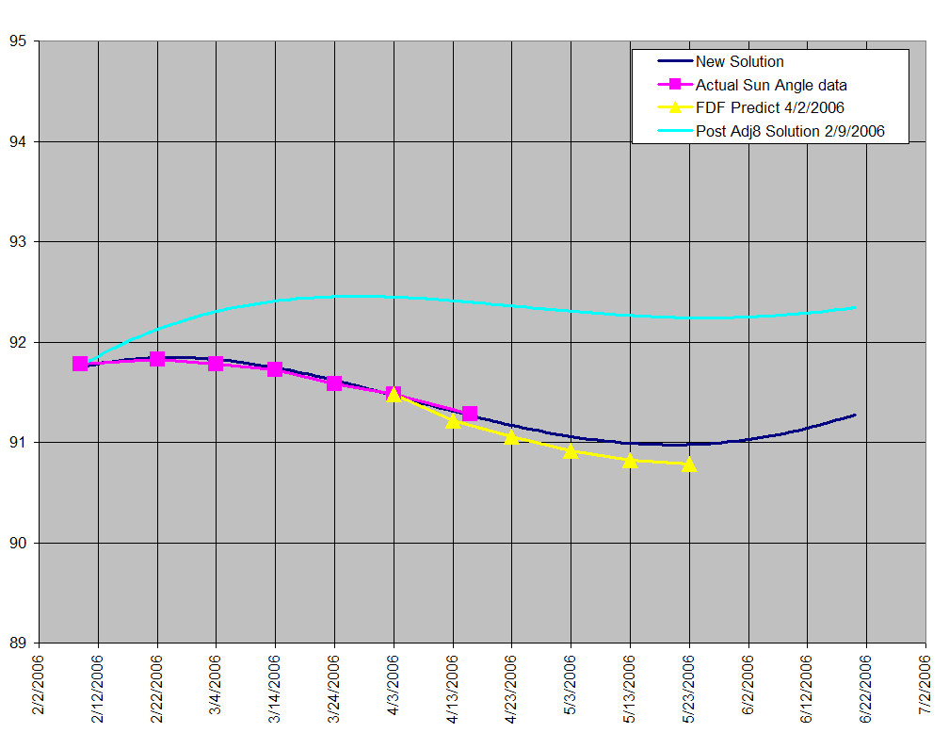

Sun Angle Maneuver

The next Polar maneuver is tentatively scheduled for October 21, 2006

2. Polar SWT Meeting

The next Polar Science Working Team meeting will take place on June 7-8, 2006, at The Doubletree Hotel & Executive Meeting Center, Berkeley Marina, Berkeley, CA USA. The meeting web site can be found at
http://pwg.gsfc.nasa.gov/polar/ Registration for the meeting is open now. A group rate has been negotiated with the hotel. This will be available as soon as all of the contracts are signed. A reminder message will be sent out when the hotel reservations are available. We anticipate a full day of science presentations and an operations discussion on the first day, with a continuation of science presentations on the second. It is anticipated that the meeting will finish at 3pm on the second day allowing people plenty of time to catch evening flights. There will be a registration fee of $140 which will include breakfast, lunch and snacks for both days. We will be going out to a local restaurant for a group dinner on the Wednesday evening (7th).

3. Resident Archives
The Polar mission is directed to write a white paper proposing the structure of resident archives for the Polar data. We are encouraged to take as many cost saving measures as possible (i.e.) combining data sets within institutions or across institutions where it makes financial sense. This white paper on the Polar resident archives is due June 1, 2006.

Previously we had agreed on the following principles for the resident archives:

1. The resident archives are to be distributed at the PI institutions or their designated locations where the expertise in handling the specific data resides. (GSFC is not to be the sole repository for all of the data).

2. Maximal support might be of order 1/4 FTE (i.e., ~$50 K plus hardware maintenance)

3. The archives should provide the highest possible resolution (spatial and temporal).

4. The data should be available without human intervention.

5. The archive should provide dynamic access to virtual observatories.

6. Every site should provide direct links with brief descriptions of every other Polar site.

7. Every archive should allow ASCII downloads of low and high resolution data for replotting by the requestor.

8. Every site should allow plots of the data, either previously made or made on demand

9. Positional and attitude information for the Polar spacecraft should be provided at one or more sites.

10. Documented procedures for producing scientifically useful data from the Polar instruments will be made available and will be a fundamental element of the resident archives.

For information purposes, the instructions for this white paper are given below.

Feb 7, 2006

SUBJECT: Instructions for Resident Archive White Paper

The Heliophysics Division is transforming our ways of archiving data by adopting the concept of resident archives. Typically while a mission is active, its data are served to the research community through a loose network of data servers (active archives) that are located at mission data centers and instrument sites as well as at multimission servers such as the Solar Data Analysis Center and the Space Physics Data Facility. We are finding that because of advances in information technology, it is desirable and cost effective to continue serving mission data under the supervision of the mission’s data providers; i.e. “resident” with the scientists that produced the data. The architecture for networks of resident archives is diffuse and all resident data sets will not stand alone. The concept allows for grass roots consolidation of data servers along institutional lines, along lines of comparable instruments, as well as along mission lines or in the multimission data facilities. Resident archives need to seek their own low-cost solutions for continuation of service.

The period of “residence” will not be “forever”. The resident archives will be subject to periodic peer reviews to determine if the archive is still of value to the research community, if it should it be merged with other resident archives, or if it should be terminated with the data sets going to NASA’s permanent data archives. We are formulating the processes for initiating, maintaining, and reviewing resident archives.

Recent experiences have shown that when a veteran mission retires, its data are not quite ready for their resident archive(s). There is work to be done by the science team before it disbands. Most instrument teams have lists of unfinished tasks, improvements and updating documentation that are important but have not been done due to higher priority activities while the mission is still operating.

Prepare and submit a white paper by June 1, 2006, discussing your concepts and configuration for establishing one or more resident archives upon termination of your mission. In addition, consider the hypothetical situation that your mission failed tomorrow and describe those unfinished tasks that need to be done to serve your data to the community from the resident archive. List the tasks in priority order with the idea that the most important tasks will be accomplished within one year following the cessation of operations. The less important may be accomplished under the sponsorship of one of our competitive research programs.

4. MFE Data Processing Status

5. The CAMMICE Science Report

The CAMMICE Science Report (Powerpoint)

The CAMMICE Science Report (PDF)

